**Honors Algebra Name:**

**10.1-10.4 (with p.641 extension & 11.2) Review Period:**

**(1-3) Graph the following quadratic functions. Draw at least three accurate points and sketch in the axis of symmetry. Then, complete the information about each graph.**

1. 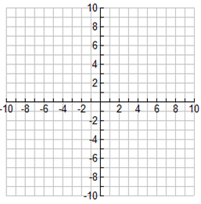

*y*-Intercept:

*x*-Intercept(s):

Vertex:

Axis of Symmetry:

Graph Opens: Up / Down (circle one)

1. 

*y*-Intercept:

*x*-Intercept(s):

Vertex:

Axis of Symmetry:

Graph Opens: Up / Down (circle one)

1. 

*y*-Intercept:

*x*-Intercept(s):

Vertex:

Axis of Symmetry:

Graph Opens: Up / Down (circle one)

**(4-6) State whether the functions below have a maximum or minimum value. Then identify that value.**

1. 
2. 
3. 

**(7-9) Identify how many solutions the functions below have. Then find the x-intercepts.**

1. 
2. 
3. 

**(10-12) Use your calculator to find the vertex and x-intercept(s) of the functions below.**

1. 
2. 
3. 

**(13-17) Simplify. Leave no radicals in the denominator.**

1. 
2. 
3. 
4. 
5. 

**(18-24) Solve for *x*. If necessary, round solutions to the nearest hundredths place.**

1. 
2. 
3. 
4. 
5. 
6. 
7. 